Assignment 2: Basics of Linux and Open-Source Tools
Course: Computer Science Fundamentals & Career Pathways
(ETCCCP105)

Programme: B.Tech CSE (FULL STACK
DEVELOPMENT)
Semester: 1
Faculty: Dr. Ravinder Beniwal
Student Name: ADITYA DAGAR
Roll no: 2501350081

Assignment Title: Demonstrating Linux Setup, Command
Usage, and Automation Through Practical Implementation

- Introduction
Linux is one of the most powerful and flexible operating systems used in both academics and industry. It is opensource, secure, and widely used for programming, networking, and server management.
This assignment helped me understand how Linux works and how to use it for daily tasks. I learned to install Ubuntu, use different terminal commands, write shell scripts, and upload my work to GitHub. Doing everything step by step made me realize how important command-line practice is for programmers.

- Linux Installation
I installed Ubuntu 22.04 using VirtualBox on my Windows 11 system.
The system configuration was:
- Processor: Intel Core i7 13700hx
- RAM: 16 GB
- Disk Space: 100 GB allocated for Ubuntu

Installation Steps:
- Downloaded the Ubuntu ISO file from the official website.
- Installed Oracle VirtualBox and created a new virtual machine.
- Allocated memory, storage, and attached the ISO file.
- Started the VM and followed on-screen steps to install Ubuntu.
- Created a username and password for login.
- After installation, updated the system using the command:

All screenshots are attested below this page

How to install virtual box and ubuntu
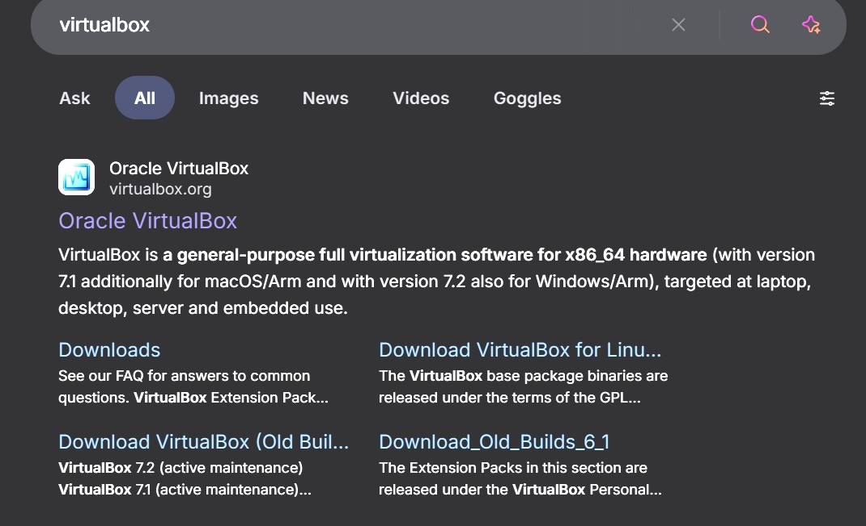
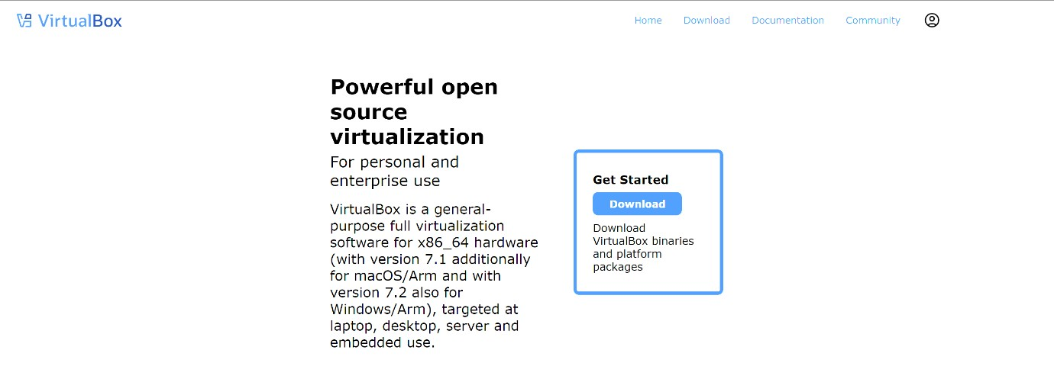
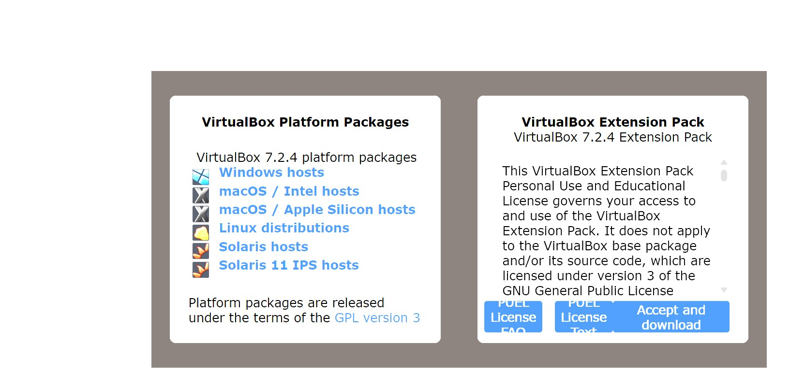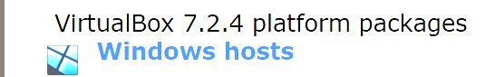
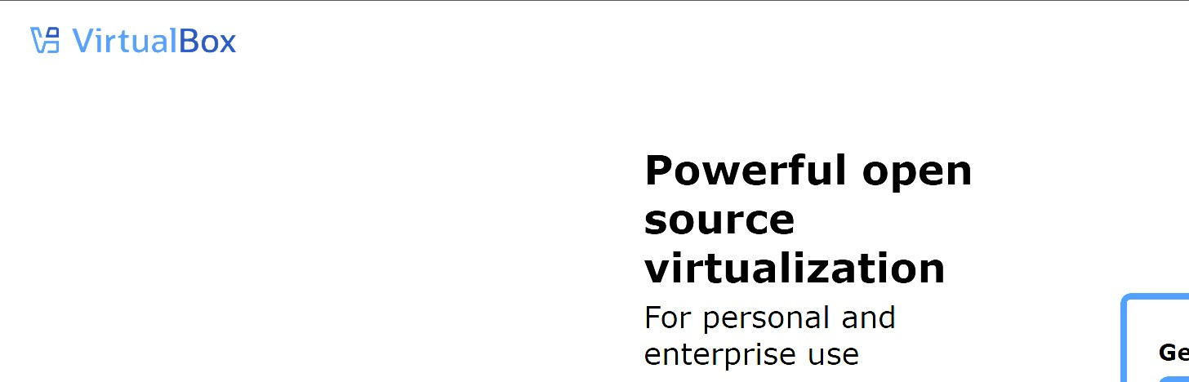
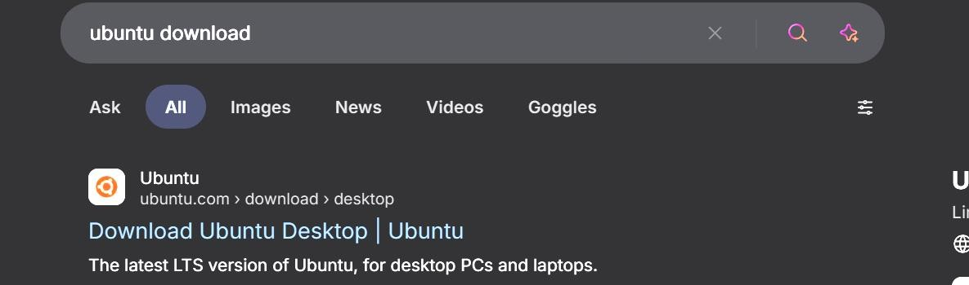
How to setup virtual box and ubuntu
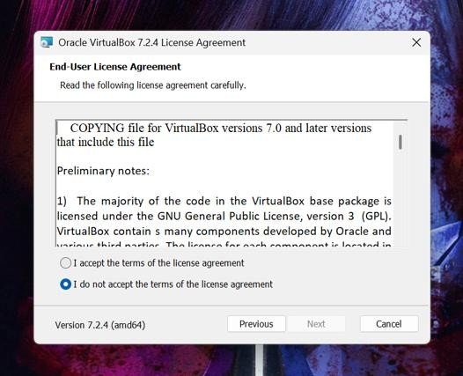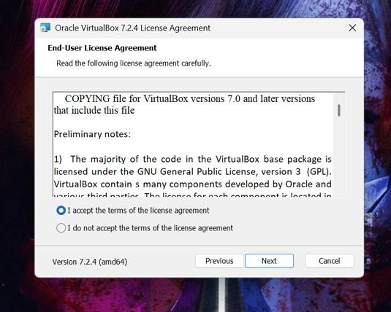

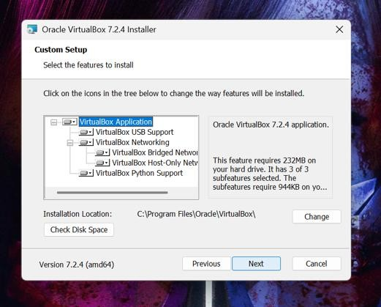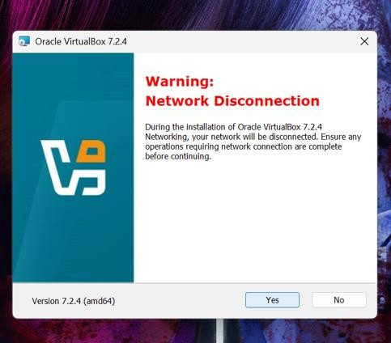
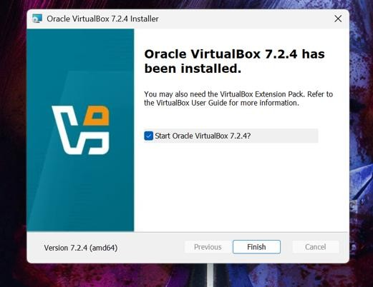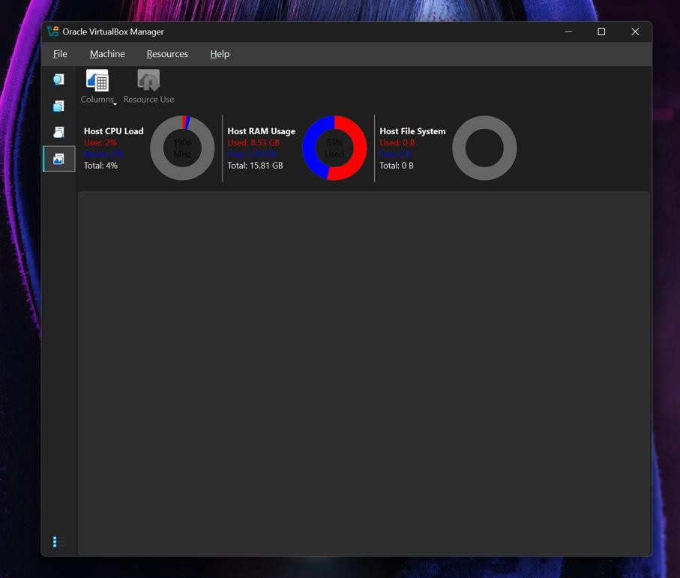

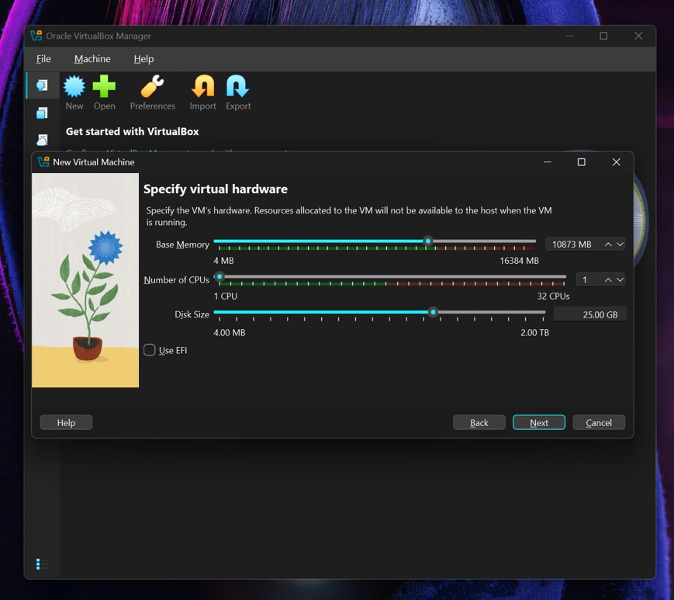

- Shell Commands and Their Use
I performed more than 20 Linux commands and noted their use. Below are some examples:
Command Syntax / Example Purpose / Description
pwd | pwd | Shows current working directory.
ls | ls -l | Lists all files and folders in a directory.
cd | cd Documents | Changes the current directory.
mkdir | mkdir myfolder | Creates a new folder.
rmdir | rmdir myfolder | Removes an empty directory.
cp | cp file1.txt backup/ | Copies a file to another location.
mv | mv file.txt  newname.txt | Moves or renames a file.
rm | rm file.txt | Deletes a file.
cat | cat notes.txt | Displays contents of a file.
touch | touch newfile.txt | Creates an empty file.
chmod | chmod 755 file.sh | Changes file permissions.
chown | chown user:user  file.txt | Changes file ownership.
ps | ps | Shows running processes.
Command Syntax / Example Purpose / Description
top | top | Displays system performance.
kill | kill 1234 | Kills a process using its PID.
ping | ping google.com | Checks network connectivity.
ifconfig | ifconfig | Displays network interface details.
clear | clear | Clears the terminal screen.
whoami | whoami | Displays current logged-in user.
tree | tree | Shows folder structure in tree form.

4. Shell Script Development
I wrote three small shell scripts as part of the assignment. Each one was tested on Ubuntu.

a) Backup Script

Filename: backup.sh
#!/bin/bash # Script to back up a folder with timestamp

src="/home/user/Documents" dest="/home/user/backup" timestamp=$(date +%Y-%m-%d_%H-%M-%S)

mkdir -p "$dest" cp -r "$src" "$dest/backup_$timestamp"

echo "Backup completed successfully at $timestamp."

b) CPU/Memory Monitoring Script
Filename: monitor.sh #!/bin/bash # Script to log CPU and Memory usage

logfile="/home/user/system_usage.log"

echo "System usage on $(date)" >> $logfile top -b -n1 | head -n 10 >> $logfile echo "--------------------------------" >> $logfile

echo "System usage logged successfully."

c) File Download Script
Filename: download.sh #!/bin/bash # Script to download a file using wget

url="https://example.com/sample.pdf" dest="/home/user/Downloads"

wget -P $dest $url

echo "File downloaded to $dest"

• This is the whole assignment

This assignment was a very good learning experience.
At first, using the terminal was confusing, but with practice, I started understanding how powerful it is. I learned how to automate tasks using simple scripts and how GitHub helps in saving and sharing code.
It also helped me realize the importance of open-source software in the real world. The most challenging part was writing correct syntax in shell scripts, but after testing and debugging, it became easier.

